

**Geethanjali College of Engineering and Technology**

**(Autonomous)**

**(Approved by AICTE, permanently affiliated to JNTUH, accredited by NAAC with ‘A’)**

**Cheeryal(V), Keesara(M), Medchal Dt., Telangana-501301**

**Project: Program to maintain student profiles**

**P. Baby Shiva Naga Sriya(21R11A0595),**

**V.Sujith Kumar(21R11A05A2)**

**K.SaiTeja(22R11A0509)**

**Guided by**

A. Sree Lakshmi (HOD CSE)

**INTRODUCTION**

This is a javabased application using GUI and MYSQLconnector to maintain student record. The application have a login page. The application take student details like name, address, branch, previous year scores, curricular and extra-curricular activities and all the entered data should be displayed in the end for conformation and it is stored in the database using MYSQL.

**SOFTWARE REQUIREMENTS:**

Java : The programming language used is Java.

MySQL: RDBMS used to maintain and handle the data is MYSQL.

SQL: The query language used is SQL.

JDBC : JDBC(API) is needed for database connection and communication between the application and database.

Mysqlconnector: It provides connectivity to the MySQL server .

**Packages**

***javax.swing***

**Java Swing tutorial** is a part of Java Foundation Classes (JFC) that is used to create window-based applications. It is built on the top of AWT (Abstract Windowing Toolkit) API and entirely written in java.Unlike AWT, Java Swing provides platform-independent and lightweight components.

The javax.swing package provides classes for java swing API such as JButton, JTextField, JTextArea, JRadioButton, JCheckbox, JMenu, JColorChooser etc.

***java.awt***

The java.awt package is the main package of the AWT, or Abstract Windowing Toolkit. It contains classes for graphics, including the Java 2D graphics capabilities introduced in the Java 2 platform, and also defines the basic graphical user interface (GUI) framework for Java. The most important graphics classes in java.awt are Graphics and its Java 2D extension, Graphics2D. These classes represent a drawing surface, maintain a set of drawing attributes, and define methods for drawing and filling lines, shapes, and text. Classes that represent graphgics attributes include Color, Font, Paint, Stroke, and Composite.

***java.awt.event***

The **java**.**awt**.**event package** defines classes and interfaces used for **event** handling in the **AWT** and Swing. The members of this **package** fall into three categories: **Events**. The classes with names ending in "**Event**" represent specific types of **events**, generated by the **AWT** or by one of the **AWT** or Swing components.

***java.io.file***

**Java**.**io package** provides classes for system input and output through **files**, network streams, memory buffers, etc. Some **input-output** stream will be initialized automatically by the JVM and these streams are available in System class as in, out, and err variable.

***javax.swing.filechooser.FileNameExtensionFilter***

An implementation of FileFilter that filters using a specified set of extensions. The extension for a file is the portion of the file name after the last ".". Files whose name does not contain a "." have no file name extension.

***java.util.Scanner***

**Scanner** Class in **Java**. **Scanner** is a class in **java**.**util package** used for obtaining the input of the primitive types like int, double, etc. and strings. ... next() function returns the next token/word in the input as a string and charAt(0) function returns the first character in that string.

**Program Details–**

1. **LoginFrame** :

Login Frame is GUI based window that is displayed when the user first executes the program. It is the welcome page through which user will move on to the next frame.

It contains a button with an ActionListener() which on pressing opens Frame2.

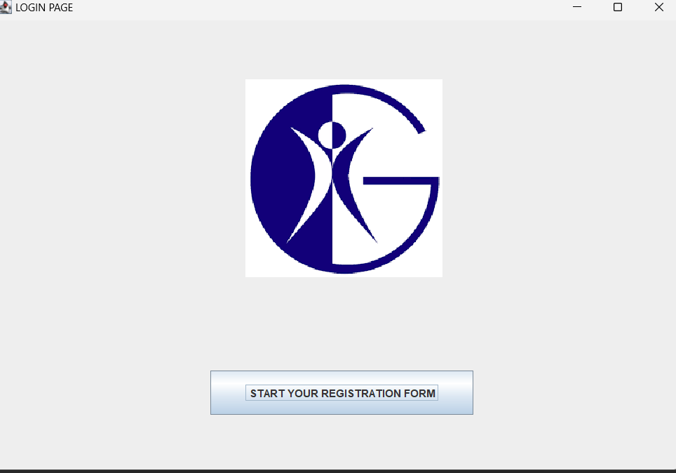

1. **Frame2** :

Frame2 is login page. This page takes userid and password as input and only after successful verification of user the user is allowed to move to next page.

The default user id password is

User id :- admin

Password:-admin1234

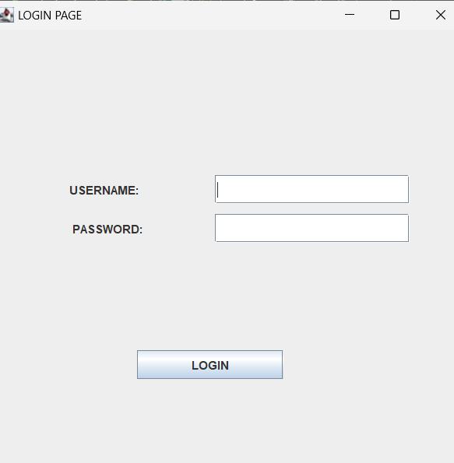

If user enter default username and password then it moves to next page

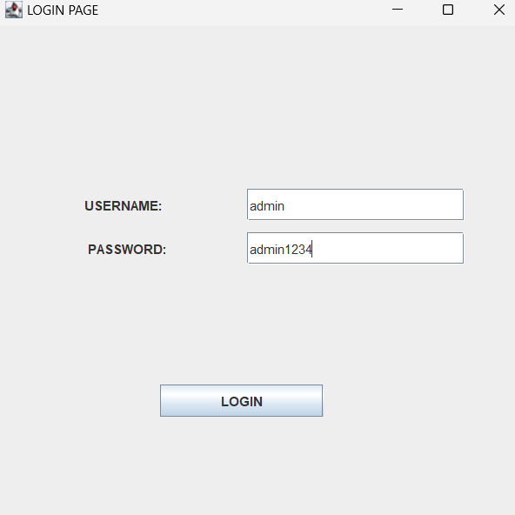

If the user enters wrong id or password it shows a alert box userid or password is wrong

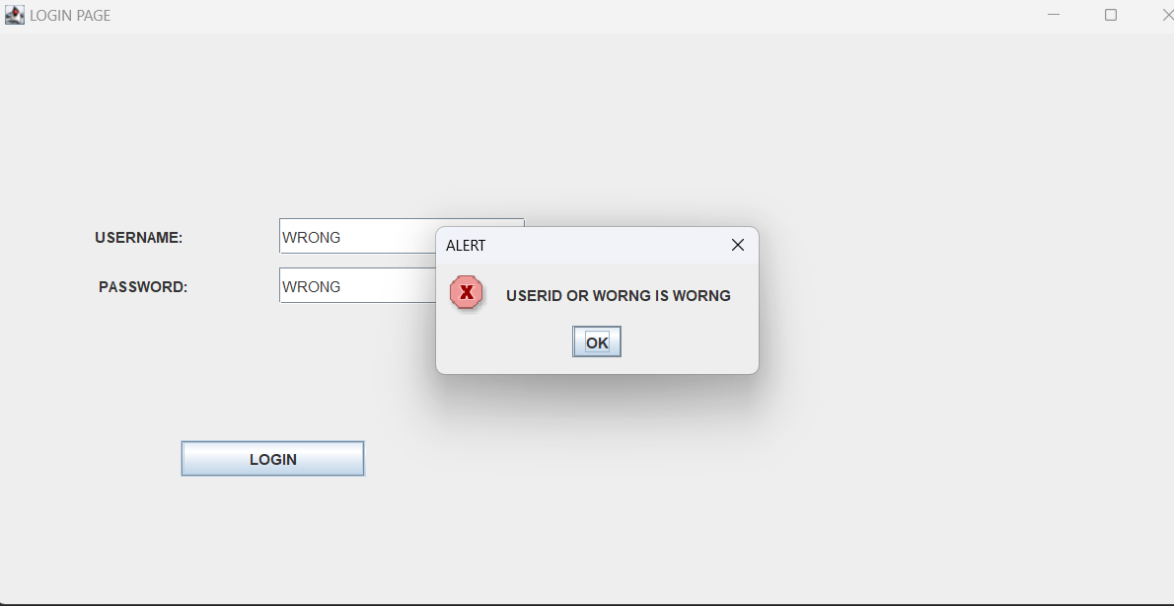

1. **Frame3** :

Frame3 is where the user is given the option to enter their details such as name, age, branch, address and select their gender from the drop-down menu. Each detailto be entered are stored using JTextField() and JRadioButton is used to display the drop-down menu for the gender selection. Finally, there is the submit details button which on pressing triggers ActionListener() and checks whether the user given input is legitimate or not, if it is not then it pops a alert message that reminds the user to enter the correct details. Once the correct given,

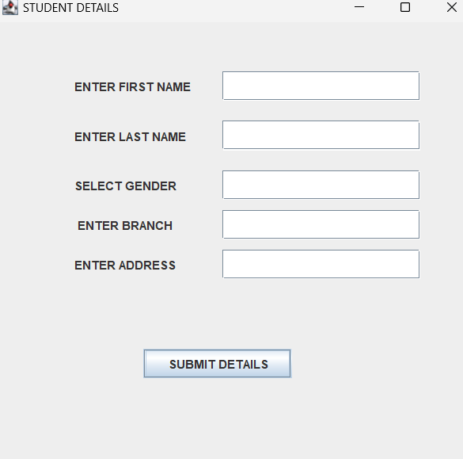

we pass this information onto Frame4. 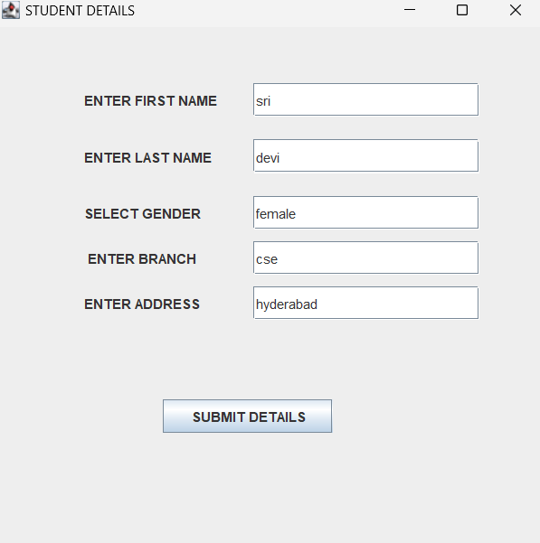

1. **Frame4** :

Frame4 is where the user is given the option to enter their details such as their previous academics achievements, their 10th,12th scores, their average pointer, their extra-curricular and co-curricular activites.Each detail to be entered are stored using JTextField() and JRadioButton is used to display the drop-down menu for the gender selection. Finally, there is the submit details button which on pressing triggers ActionListener() and checks whether the user given input is legitimate or not, if it is not then it pops a alert message that reminds the user to enter the correct details. Once the correct input is given, we pass this information onto Frame5.

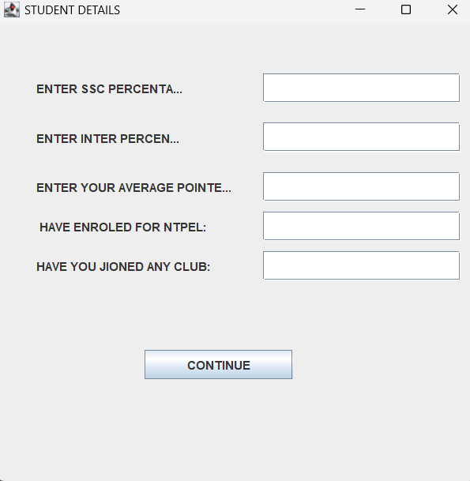

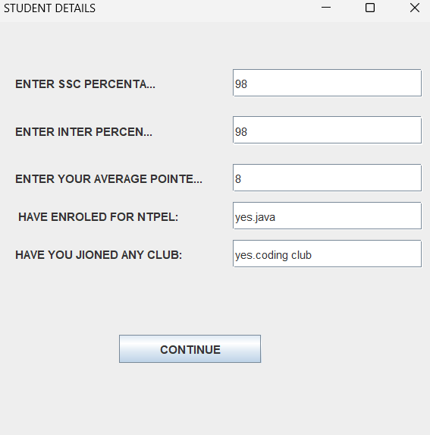

1. **Frame5 :**

Frame5 class is where we receive the user input taken in Frame3 and Frame4 and using JLabel()’s we display it on our Java application windows. There are two buttons to either make a new entry or to exit. On clicking on the first button, ActionListener() is triggered which calls Frame3() and thus we can enter details of the another entry. th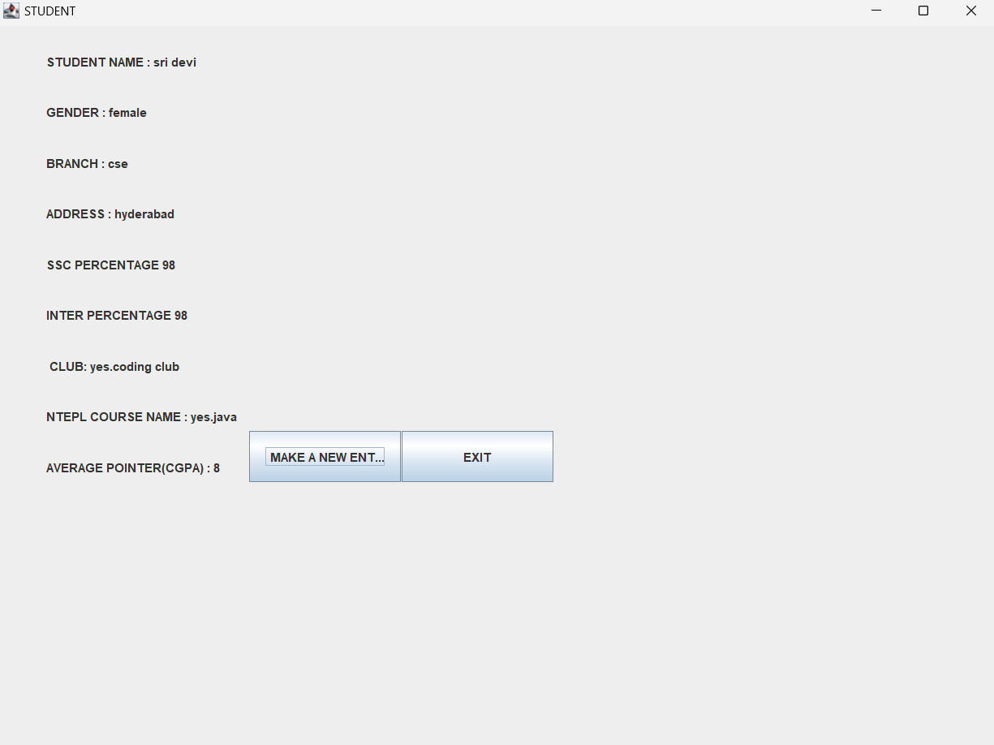

1. **Student Detials :**

This is the final class that contains the main method, which calls the LoginFrame() .

DATABASE OUTPUT

Program is connected to MYSQL database connector .It will create a database automatically

1)When the data is not entered it shows emptyset

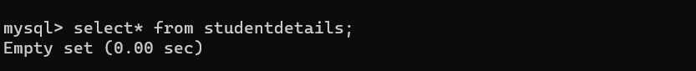

**2)when the data is entered it shows data in table format in the database**

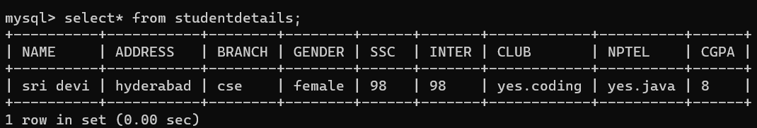

**AWT/Swing Functions Used –**

1. **ActionListener:**

ActionListener in Java is a class that is responsible in handling all action events such as when user clicks in component, like JButton, the moment user clicks on it, the ActionListener immediately enforces the action which was programmed by the programmer.

E.g.

b1.addActionListener( new ActionListener()

{

Publicvoid actionPerformed(ActionEvent e)

{

LoginFrame.this.setVisible(false);

new Frame2();

}

});

In this example we can see that an ActionListener is added to the JButton b1, then an action is programmed to take place using the actionPerformed() function. “new Frame2()” is action set by the user that creates a new Frame

1. **JFrame :**

The JFrame class is a type of container which inherits the java.awt.Frame class. JFrame works like the main window where components like labels, buttons, textfields are added to create a GUI. It is a container in which you put all the elements of your window in a GUI application.

Unlike Frame, JFrame has the option to hide or close the window with the help of setDefaultCloseOperation(int) method

**3) JButton :**

The JButton class is used to create a labeled button that has platform independent implementation. The application result in some action when the button is pushed. It inherits AbstractButton class.

Constructors of the class are:-

**JButton()** – To create a button with no text and icon.

**JButton(String s)** – To create a button with the specified text.

**JButton(Icon i)** – To create a button with a specified icon object.

1. **JLabel :**

JLabel is a class of java Swing . JLabel is used to display a short string or an image icon. JLabel can display text, image or both . JLabel is only a display of text or image and it cannot get focus . JLabel is inactive to input events such a mouse focus or keyboard focus. By default labels are vertically centered but the user can change the alignment of label.

Constructor of the class are :

**JLabel()**- creates a blank label with no text or image in it.

**JLabel(String s)**- creates a new label with the string specified.

**JLabel(Icon i)**- creates a new label with a image on it.

JLabel(String s, Icon i, int align) - creates a new label with a string, an image and a specified horizontal alignment

1. **JTextField –**

JTextField is a part of javax.swing package. The class JTextField is a component that allows editing of a single line of text. JTextField inherits the JTextComponent class and uses the interface SwingConstants.

The constructor of the class are :

**JTextField()** : constructor that creates a new TextField

**JTextField(int columns)** : constructor that creates a new empty TextField with specified number of columns.

**JTextField(String text)** : constructor that creates a new empty text field initialized with the given string.

**JTextField(String text, int columns)** : constructor that creates a new empty textField with the given string and a specified number of columns .

**JTextField(Document doc, String text, int columns)**: constructor that creates a textfield that uses the given text storage model and the given number of columns.

CONCLUSION:

Maintaining student profile data in database becomes convenient with the help of GUI and MYSQLconnector.